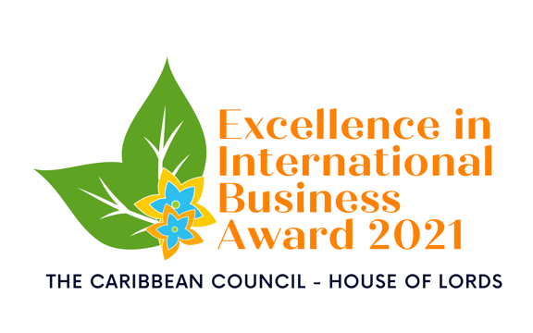
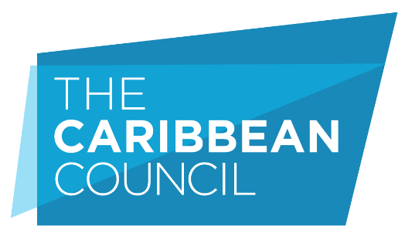

EXCELLENCE IN INTERNATIONAL
BUSINESS AWARD 2021

ENTRY FORM

YOUR DETAILS
Business name
Job title
Contact name
Email
Telephone
Address
Country
Business website
If you are nominating an organisation:
Nominated Organisation Name
Address
Country
Website

By submitting this form you agree that all facts and figures contained within are accurate and true and if a self-nomination, that permission to enter has been given by the relevant authority within the company.

Please complete the following sections. All answers supplied must be within the 1000-word count. (Minimum font size – 10)
ELEVATOR PITCH
Why the company should win (75 words)

DESCRIBE AND EXPLAIN HOW THE BUSINESS ACHIEVED SUCCESS BY COMPLETING THE FOLLOWING SECTIONS:
Reasons for launching the business
Evidence of sustainable growth
Innovation
Customer service and benefits
Employee engagement
Investment in technology
Leadership
Skills development
Financial performance
Last 2 years, present and future projections for Sales and Profitability
Please detail any supporting materials and testimonials you are submitting
Please attached supporting documents when submitting this entry form (4 sides of A4 maximum)

Please email entry form and supporting documents to:
Maria Tereza Laino at mariatereza.laino@caribbean-council.org

